Linux Assignement-10
Name-Vishwas.M
Class & section-3C
Usn-ENG24CY0197
Roll.no-32

1) journalctl --vacuum-time=7d
(1) What is the said commands (little history, invention, authors of the command)?
Soln :- journalctl is the command used to read and manage logs stored by systemd-journald, the logging service in modern Linux distributions.
- History & Origin
Created: 2010
- Original Authors
Lennart Poettering
Kay Sievers
Developed under Red Hat
- systemd replaced old init systems and brought modern logging through journald.
Purpose
Earlier Linux logs rotated through /var/log/*.log, but journald stores binary logs, requiring special cleaning methods like --vacuum-time.

(2) Why the particular commands are useful for System administrator?
Soln :- System admins use this command because:
1. Controls log file size
Prevents system logs from filling up disk space.
2. Automatically cleans old logs
No need for manual deletion.
3. Helps maintain system performance
Huge journal logs slow down searches and indexing.
4. Essential in production environments
Servers generate GBs of logs — cleaning is critical.
5. Keeps only recent logs required for incident analysis
Keeps logs for the last 7 days (can customize).
(3) How these said commands are working? Give proper example.
Soln : Main command
sudo journalctl --vacuum-time=7d
Deletes all systemd journal logs older than 7 days.
Other useful variations
- Keep logs only for last 3 days:
sudo journalctl --vacuum-time=3d
- Delete everything older than 12 hours:
sudo journalctl --vacuum-time=12h
- Delete logs older than 1 month:
sudo journalctl --vacuum-time=1month
- Combine with size limit:
sudo journalctl --vacuum-size=500M
Ensures logs never exceed 500 MB.

(4) Few snapshots of the command execution with proper illustration.
Soln : - Snapshot 1 – Run the vacuum command
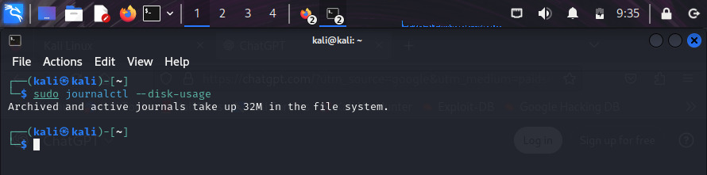
Snapshot 2 – cleaning
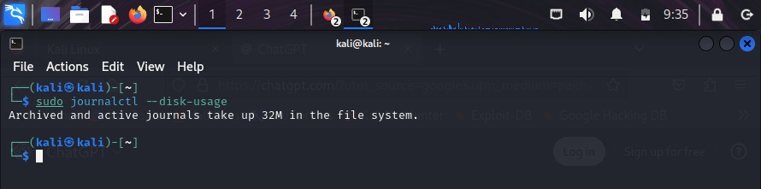
(5) At least elaborate five to six Option and Flags related to the said command. Give sources for detailed flags and options.
Flag / Option | Description
--vacuum-time= | Keep logs newer than specified time (e.g., 7d, 2h, 1month).
--vacuum-size= | Reduce journal logs until they fit within a size limit.
--vacuum-files= | Keep only a certain number of journal files.
-u <service> | View logs of a specific service (before vacuum).
--disk-usage | Shows total size used by journal logs.
--rotate | Forces journald to rotate logs immediately.

2) lxc
(1) What is the said commands (little history, invention, authors of the command)?
Soln : - LXC stands for Linux Containers — a technology that allows isolated Linux environments, similar to lightweight VMs but without the heavy overhead.
History & Origin
- Started: 2008
- Stable release: Around 2014
- Creators: Primarily developed by Stéphane Graber, Serge Hallyn, and the community under Canonical (Ubuntu).
- Based on Linux kernel features:
  - cgroups (control groups)
  - namespaces
  - AppArmor / Seccomp
Purpose
To create OS-level virtualization without needing full hypervisor-based VMs like VirtualBox or VMware.
(2) Why the particular commands are useful for System administrator?
Soln : - 1. Create lightweight isolated environments
Perfect for:
- testing
- development
- running microservices
2. More efficient than Virtual Machines
Consumes fewer resources (RAM/CPU).
3. Easy backup, cloning, and migration
Using:
lxc-copy
lxc-snapshot
4. Better security isolation
Containers have:
- separate networking
- separate filesystem
- separate process namespaces
5. Automate deployment
Useful for CI/CD pipelines and dev environments.
(3) How these said commands are working? Give proper example
Soln : -
Example 1 — Create a new container
sudo lxc-create -n test-container -t ubuntu
Example 2 — Start a container
sudo lxc-start -n test-container
Example 3 — Stop a container
sudo lxc-stop -n test-container
Example 4 — View running containers
sudo lxc-ls --fancy
Example 5 — Enter container shell
sudo lxc-attach -n test-container
Example 6 — Destroy a container
sudo lxc-destroy -n test-container

(4) Few snapshots of the command execution with proper illustration.
Soln:- Snapshot 1 – Listing containers

Snapshot 2 – Starting container

Snapshot 3 – Shell inside container

(5) At least elaborate five to six Option and Flags related to the said command. Give sources for detailed flags and options.
Command / Option | Description
lxc-create | Create a new container
lxc-start | Start the container
lxc-stop | Stop a running container
lxc-destroy | Delete the container
lxc-ls --fancy | List containers with details
lxc-attach | Enter the shell of a running container
lxc-info | Display container status
lxc-copy | Clone an existing container

